3.1 Defining the Derivative

So far, we have been discussing limits and how they are computed. However, one of main goals in Calculus I is to develop the mathematics necessary to find the tangent line to a curve at a point. We begin with an intuitive definition of tangent line.

Definition (Intuitive): A tangent line (or tangent) to a curve is a line that touches the curve. A tangent line should have the same direction as the curve at the point of contact, and the tangent line should do a good job of approximating the curve near the point of tangency.

Definition: A secant line is a line that intersects a curve more than once.

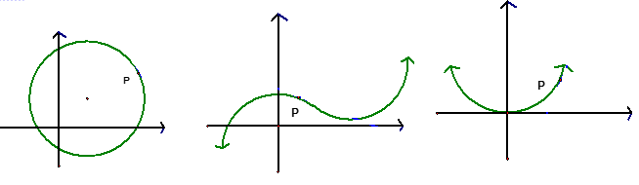
Example 1: Sketch a tangent line to each curve at the point P.

Question: What would a tangent line to a linear curve look like?

Recall: To actually give the equation of a tangent or secant line we need to recall…
- the slope intercept form of the equation for a line is:

- the point-slope form of the equation for a line is.

Example 2: Consider the curve given by .

- Find an equation of the line secant to the curve that goes through P: (1,1) and Q: (1.5, 2.25).

- Find a formula for the slope of the line secant to the curve that goes through P: (1,1) and R: (assuming )

- What would you conjecture is the slope and equation of the tangent line to the curve at P: (1,1) .

Armed with the knowledge of what a limit is, we can give a rigorous definition of tangent line to a curve.
Definition: The tangent line to the curve at the point P: is the line through P with slope: provided this limit exists.

Note: The pictures below capture the idea of the definition. When looking at the pictures keep in mind what x and h are approaching.
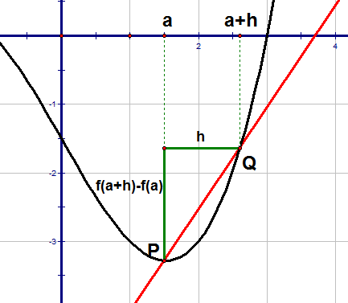
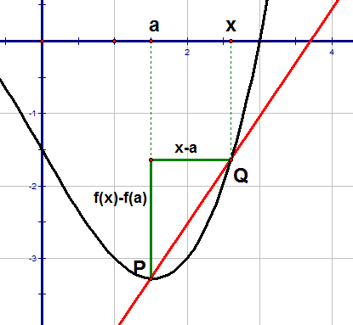

Note: If time permits the instructor will do a computerized secant line demonstration.
Example 3: Find an equation of the tangent line to the curve at the point .

Example 4: Find the slope of the tangent line to the curve at the point .

Definition: Suppose an object moves in a straight line according to an equation of motion . The function is called the position function of the object.

The average velocity of the object over the time interval from to is
.
The instantaneous velocity of the object at time is .

Example 5: Suppose that a delivery man drives on a straight line away from a depot to make deliveries. The function yields his distance from the depot where s is in miles and t is in hours
- Find the average velocity of the truck from 2 hours to 3 hours.

- Find the instantaneous velocity of the truck at 2 hours.

Example 6: Find a general formula for (i.e. the instantaneous velocity at time t) using the position function from the most recent example.

Note: From the above example . So, we obtain the result from part (b) of the first example. The result of the example is quite powerful because we can use it to find the instantaneous velocity at ANY time.
At this stage in the class we have seen show up in two different applications: the slope of a tangent line and instantaneous velocity. This limit is so important that we associate a special name with it.
Definition: The derivative of a function f at a number a, denoted by , is:

Another equivalent way of defining this is: .

Example 7: Suppose that . Find .

Example 8: Suppose that . Find , and give an interpretation of what means.

Terminology: A derivative is a rate of change. Suppose . If x changes from to , we call the change in x: , and the corresponding change in y is: .

If we want to know the average rate of change of y with respect to x, the obvious thing to do is find:

If we want to know the instantaneous rate of change of y with respect to x at , the obvious thing to do is find:

